HUSSEINI SULEIMAN
2025/FWSD/11478
fwsd2511478@students.icdfa.edu.ng
DATE: 28TH AUGUST, 2026
COURSE CODE: SBT-DF202 · Practical Laboratories

Lab 2 — USB Image Acquisition and Hash Verification

Scenario

Your practical context
You are acting as a junior digital forensic trainee. A USB flash drive has been submitted for examination. Your task is to document the evidence, acquire a forensic image of the USB using an approved method, calculate and compare cryptographic hashes, verify the integrity of the acquired image, confirm that the expected evidence file is present, and prepare a repeatable forensic acquisition report.
Objectives

What you must demonstrate
By completing this lab, students will demonstrate their ability to explain the purpose of forensic disk imaging, prepare controlled USB evidence, acquire a forensic USB image using FTK Imager on Windows or dd/dcfldd on Linux, calculate MD5 and SHA-256 hash values, compare source and image hashes for integrity verification, validate the contents of the acquired image, identify risks associated with low-level imaging tools, and document the complete acquisition process with professional screenshots and evidence notes.
Instructor briefing

Laboratory guidance
Before beginning this lab, review the Module 3 lessons and study materials covering forensic disk imaging, USB acquisition, FTK Imager, dd, dcfldd, and hash verification.
Use only a personal or instructor-approved test USB drive. Do not use a third-party, organisational, or production device. Carefully identify the USB before acquisition because selecting the wrong device with a low-level imaging tool can result in data loss.

Part A - Prepare the USB Evidence
Create a folder on the test USB named:
CIP-B102-Lab4-Evidence
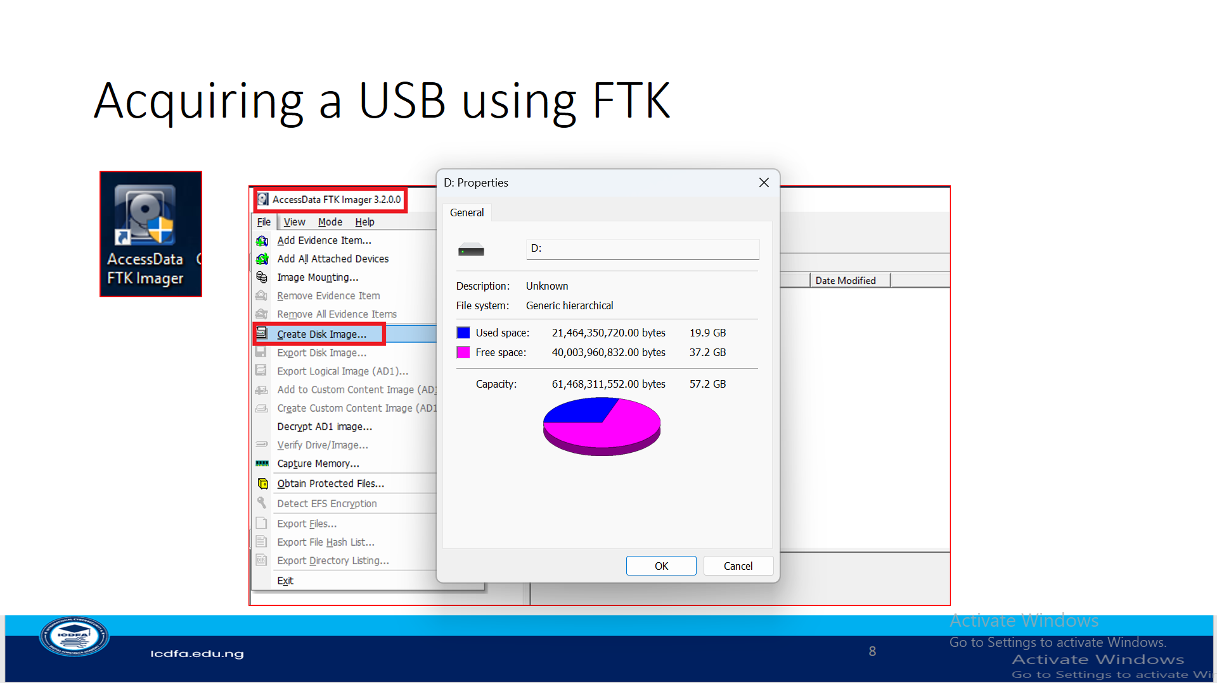
Inside the folder, create:
firstname_lastname.txt
The file must contain your full name, registration number, date, and a statement confirming that the USB was prepared for a controlled forensic acquisition lab.
You may also add one image and one PDF file to provide additional file types for validation.

Part B - Complete Evidence Documentation
Before acquisition, record:

- Case/Lab ID: CIP-B102-Lab4-Evidence
- Student name: HUSSEINI SULEIMAN
- USB brand/description: SANDISK FLASH
- USB capacity: 64GB
- Date and time prepared: 29TH AUGUST, 2026 10:35AM
- Acquisition method: WINDOWS
- Tool and version:
- Image filename: CIP-B102-Lab4-Evidence
- Image storage location: VENTOY/ CIP-B102-Lab4-Evidence

- Hash algorithm used

Part C - Acquire the USB Image
Complete at least one approved acquisition method.
Option A - Windows using FTK Imager
Use FTK Imager to create a forensic image of the USB. Carefully verify the selected device, use Raw/DD where applicable, record evidence information, save the image to your computer rather than the source USB, and enable verification after imaging.
Option B - Linux/Kali using DD
Identify the USB using lsblk or fdisk, unmount the USB partition if necessary, and acquire the whole USB device using an appropriately constructed dd command.
Example structure:
sudo dd if=/dev/sdX of=~/CIP-B102-Lab4/CIPB102_Lab4_Firstname_Lastname_USB.dd bs=4M status=progress conv=noerror,sync
Replace /dev/sdX with the actual USB device identified on your system. Do not copy the example device name blindly.
dcfldd may also be used where available.

Part D - Hash Verification
Calculate MD5 and SHA-256 hashes for both the original source USB and the acquired image.
Compare the values and document whether they match. If they do not match, explain the possible cause and repeat the acquisition if required.

Part E - Validate the Acquired Image
Confirm that your acquired image contains firstname_lastname.txt.
You may validate the image using either:
- FTK Imager, by adding the .dd image as an evidence item and locating the file, or
- Linux read-only mounting, where supported.
The source lab requires students to demonstrate that the expected evidence file is actually present in the forensic image.
Document every major step with clear screenshots and explanatory notes.
Required evidence
USB visible on the acquisition system.
CIP-B102-Lab4-Evidence folder and firstname_lastname.txt.
Contents of the student-created evidence file.
Completed evidence acquisition information.
Correct source USB identification.
Acquisition command/tool configuration and completion.
MD5 and SHA-256 hashes of source and image.
Proof that the acquired image contains firstname_lastname.txt.
Final PDF report with screenshots, reflection and conclusion.
Lab access notesThis practical forms part of the first laboratory assessment window. Use only a personal or instructor-approved test USB. Carefully identify the correct device before imaging. Students must preserve the source evidence, calculate and compare hashes, and demonstrate that the acquired image contains the expected evidence file. Submission must include the required professional PDF report and supporting evidence.
New practical submission

Submit lab evidence
Your evidence and wallet debit are committed together as one controlled transaction.

